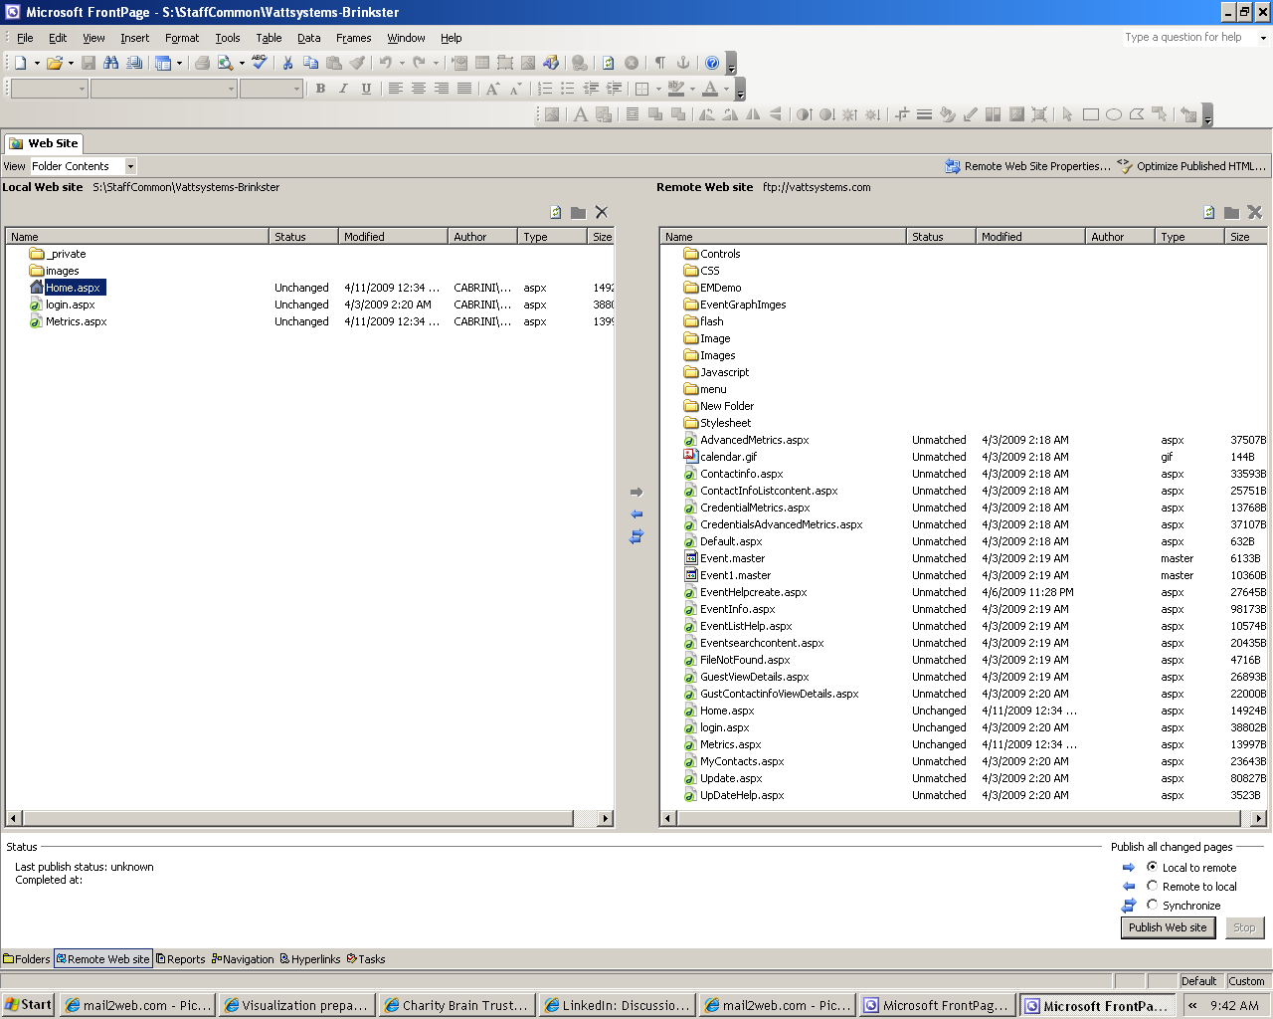

4/17/09

I was able to log in and get to this point. I copied the metrics and home page from the right side to the left side.

When I clicked to open, all I got was a blank page.

Dan

